 |  | Adachi, Emi |  | 2020
 |  | Heitman
 |  | Senior Vice President/Deputy Director
 | 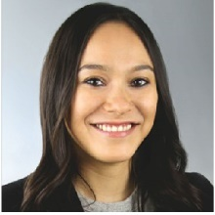 | Res: 2125 W, Dickens Avenue, Chicago, IL, 60647 |  | Cell: 773-988-8585
 |  | Bus: 191 N. Wacker Drive, Suite 2500, Chicago, IL, 60606 |  | Bus: 312-425-0269
 |  | maiko.adachi@heitman.com
 |  | Arnburg, David |  | 2011
 |  | Gould & Ratner, Inc.
 |  | Commercial Real Estate Employee Benefits Attorney
 | 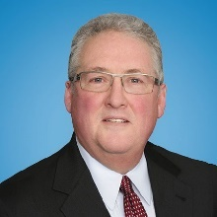 | Res: 2537 Woodland Drive, Northbrook, IL, 60062 |  | Cell: 312-933-8542
 |  | Bus: 222 N. LaSalle Street, 3rd Floor, Chicago, IL, 60601 |  | Bus: 312-899-1600
 |  | darnburg@gouldratner.com |  | Fax: 312-236-3241
 |  | Augustyn, Kevin G. |  | 2024
 |  | Morningstar DBRS
 |  | Senior Vice President
 | 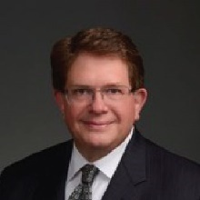 | Res: 2 North Old Mill Lane, Burr Ridge IL, 60527 |  | 630-234-9643
 |  | Bus: 22 West Washington, Suite 600, Chicago, IL, 60602 |  | Bus: 929-240-0083
 |  | kevinaugustyn8@gmail.com
 |  | Boorstein, Marc A. |  | 1996
 |  | MJ Partners Real Estate Services
 |  | Principal
 |  | Res: 441 Muirfield Lane, Riverwoods, IL, 60015 |  | Cell: 312-953-4749
 |  | Bus: 233 S. Wacker Drive, Suite 4400, Chicago, IL 60606
 |  | mboorstein@mjpartners.com
 |  | Brookover, TJ |  | 2011
 |  | AmTrust Realty Corp
 | 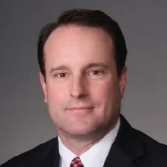 | Bus: One East Wacker Drive, Suite 250, Chicago, IL, 60601 |  | Bus: 312-661-4932
 |  | tbrookover@amtrustre.com |  | 312-661-4699
 |  | Cabanban, Todd J. |  | 2019
 |  | Cabanban, Rubin & Mayberry
 |  | Res: 6400 N. Navajo Avenue, Chicago, IL, 60646 |  | Cell: 312-371-4494
 | 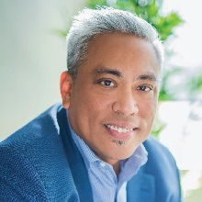 | Bus: 3660 W. Irving Park Road, 2nd Floor, Chicago, IL, 60618 |  | Bus: 312-477-0330
 |  | todd@crmcr.com
 |  | Camins, Harvey B. |  | 1996
 |  | (Senior member)
 |  | CTK Chicago Partners
 |  | Commercial Broker
 | 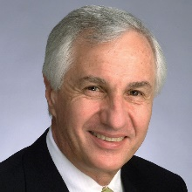 | Res: 1228 Depot Street, Unit 1C, Glenview, IL 60025 |  | Cell: 312-543-3687
 |  | Bus: 1659 West Hubbard ST, Chicago, IL, 60622 |  | Bus: 312-337-1480
 |  | hcamins@ctkcp.com |  | Fax: 312-337-1088
 |  | Caprile, Joseph P. |  | 2019
 | 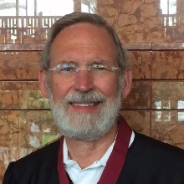 | Architect  Caprile Consulting
 |  | Res: 2615 Colfax Street, Evanston, IL, 60201 |  | Cell: 312-952-0675
 |  | Bus: 2615 Colfax Street, , Evanston IL, 60201
 |  | jpcaprile@gmail.com
 |  | Carroll, Christopher |  | 2009
 |  | Bellwether Enterprise Real Estate Capital
 |  | Res: 803 E. Illinois Street , Wheaton, IL, 60187 |  | Cell: 312-399-9810
 | 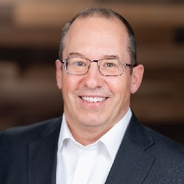 | Bus: 150 N. Wacker Drive, , Chicago, IL, 60606 |  | Bus: 312-818-5901
 |  | chris.carroll@bwe.com
 |  | Caruso, Patrick J. |  | 1991
 | 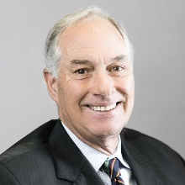 | (Senior member)
 |  | L.J. Sheridan & Co.
 |  | President & CEO
 |  | Res: 1400 Lee Road, Northbrook, IL, 60062 |  | 847-564-1882
 |  | Bus: 940 W. Adams Street, Suite 103, Chicago, IL, 60607 |  | Bus: 312-738-9501
 |  | pjcaruso@LJSheridan.com |  | Fax: 312-421-7698
 |  | Cassel, Peter |  | 2024
 |  | Mac Properties
 |  | Director  Res:505 E. 60th St, Chicago, IL 60637
 |  | Bus: 5035 S. East End Avenue, Suite N0316, Chicago, IL 60615 |  | Cell: 773-619-5649
 |  | Pcassel@macapartments.com |  | Bus: 773-347-3451
 |  | Chadha, Monica |  | 2023
 |  | Civic Projects LLC
 |  | Founder
 |  | Bus: 6100 S. Blackstone Avenue, , Chicago, IL, 60637
 |  | mchadha@civic-projects.com |  | Cell: 312-217-1570
 |  | Clark, Angela D. |  | 2024
 | 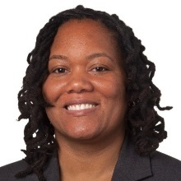 | Starbucks
 |  | Store Development Manager
 |  | Res: 1304 E. 63rd Street, Chicago, IL, 60637 |  | Cell: 773-801-8987
 |  | Bus: 111 N. Canal, Suite 450, Chicago, IL, 60606 |  | Bus: 312-401-5947
 |  | angclark@starbucks.com
 |  | Cocagne, Dave |  | 2014
 |  | Vermilion Development
 |  | Developer
 |  | Bus: 121 W. Wacker, Suite 400, Chicago, IL, 60601 |  | Bus: 312-239-3534
 | 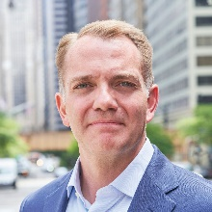 | dave.cocagne@vermiliondevelopment.com
 |  | Copley, Melissa J. |  | 2009
 |  | Newmark
 |  | Vice Chairman, Tenant Representation
 |  | Res: 1427 W. Henderson Street, Chicago, IL, 60657 |  | 773-871-6942
 |  | Bus: 500 W. Monroe St, Suite 2900, Chicago, IL, 60661 |  | Bus: 312-224-3114
 |  | melissa.copley@nmrk.com
 |  | Cornicelli, Michael F. |  | 2010
 | 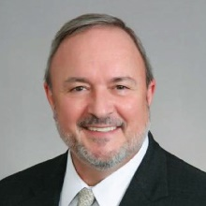 | (Senior member)  Retired
 |  | Res: 2441 Briarwood Court, Burlington, WI 53105-3410
 |  | mcornicelli@comcast.net |  | Cell: 312-860-2040
 |  | Cronin, Mary Ann |  | 2013
 |  | MAC Consulting Services
 | 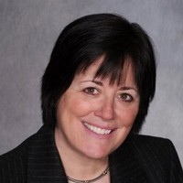 | President
 |  | Res: 701 S. Carpenter Street, Chicago, IL, 60607 |  | Cell: 312-286-8223
 |  | Bus: 701 S. Carpenter Street, Unit B, Chicago, IL, 60607
 |  | mac@macconsultingchicago.com
 | 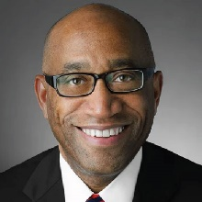 | Dawson, Randal D. |  | 2013
 |  | CBRE
 |  | Executive Vice President
 |  | Bus: 321 North Clark Street, Suite 3400, Chicago, IL, 60654 |  | Cell: 312-515-7074
 |  | randal.dawson@cbre.com |  | 312-233-8685
 |  | DeLacy, P. Barton |  | 2008
 |  | (Senior member)
 | 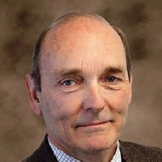 | Cushman & Wakefield
 |  | Executive Director, Valuation & Advisory
 |  | Bus: 1420 Fifth Avenue, Suite 2600, Seattle WA, 98101 |  | Bus: 206-521-10233
 |  | pbdelacy@delacycre.com |  | Cell: 503-319-8086
 |  | Delisi, Samuel C. |  | 2011
 |  | (Senior member)
 |  | Res: 1382 Prestwick Drive, Lake Geneva WI, 53147 |  | 312-543-7569
 |  | Bus: 401 N. Michigan Avenue, Suite 1900, Chicago, IL, 60606
 |  | Sam@moderneventures.com
 |  | DeVries, Jon B. |  | 1999
 | 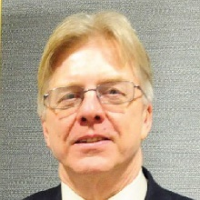 | (Senior member)  Retired
 |  | Res: PO Box 474, Preston MN, 55965 |  | Cell: 312-919-2969
 |  | jonbdevries@gmail.com
 | 
 |  | Doig, David J. |  | 2017
 |  | Chicago Neighborhood Initiatives
 |  | President
 |  | Res: 1211 South Prairie #3803, Chicago, IL, 60605 |  | Cell: 312-296-2101
 |  | Bus: 1000 East 111th Street, 10th Floor, Chicago, IL, 60628 |  | Bus: 773-341-2066
 |  | ddoig@cnigroup.org
 |  | Edwards, Michael M |  | 2021
 |  | Chicago Loop Alliance
 | 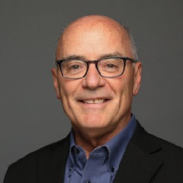 | President & CEO
 |  | Res: 1943 West Bradley Place, #2, Chicago, IL, 60613 |  | Cell: 224-251-0380
 |  | Bus: 55 West Monroe, Suite 2660, Chicago, IL, 60603 |  | Bus: 312-782-9160
 |  | michael@chicagoloopalliance.com
 |  | Enloe, Eric L. |  | 2016
 |  | Partner Valuation Advisors, LLC
 |  | Senior Managing Partner
 |  | Res: 201 W. Grand Ave, Apt PH5, Chicago, IL, 60654 |  | Cell: 816-807-6401
 |  | Bus: 1 South Dearborn Street, Suite 1530, Chicago, IL, 60603
 |  | eenloe@partnerval.com
 |  | Enright, Susan |  | 2015
 |  | Appraisal Associates
 |  | Principal, Valuation and Consulting
 |  | Res: 4545 Woodland Avenue, Western Springs, IL, 60558 |  | Cell: 312-560-6600
 |  | Bus: 65 West Jackson, Suite 125, Chicago, IL, 60604
 |  | sue@aaichicago.com
 |  | Farr, Doug |  | 2018
 |  | Farr Associates
 |  | Founding Principal
 | 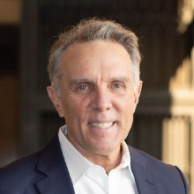 | Res: 2940 West Leland |  | Cell: 312-933-6689
 |  | Bus: 53 W. Jackson Blvd., Suite 650, Chicago, IL, 60604 |  | Bus: 312-408-1661x201
 |  | doug@farrside.com
 |  | Fisher, Laura |  | 2016
 |  | IPM Consulting, LTD
 |  | Managing Director
 |  | Res: 6 East Scott Street #2, Chicago, IL, 60610 |  | 312-280-4592
 |  | Bus: 6 East Scott Street #2, , Chicago, IL, 60610 |  | 312-859-3030
 |  | lafisher@rcn.com
 |  | Fitzgerald, Mary Kate |  | 2022
 | 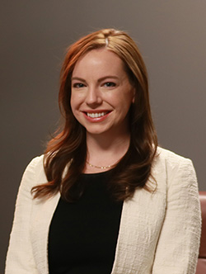 | Fitzgerald Law Group, P.C.
 |  | Partner
 |  | Bus: 7035 High Grove Blvd., , Burr Ridge IL, 60527 |  | Bus: 312-346-3000
 |  | mkf@fitzgeraldlg.com |  | Cell: 312-927-1700
 |  | Frydland, Judith |  | 2023
 |  | Judith Frydland, Attorney at Law
 |  | Attorney at Law
 |  | Res: 6571 N. Hiawatha Avenue, Chicago, IL, 60646
 |  | Bus: 53 West Jackson Blvd., Suite 1105, Chicago, IL, 60604
 |  | judy@judyfrydland.com
 |  | Gardner, Charles R. |  | 1989
 |  | (Senior member)
 | 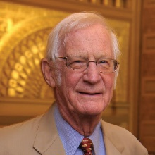 | Res: 440 N. McClurg Court, #820, Chicago, IL, 60611 |  | Cell: 312-371-3009
 |  | cdct13@aol.com
 |  | Grady, Graham C. |  | 2011
 |  | (Senior member)
 | 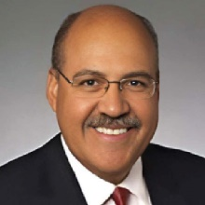 | Taft Stettinius & Hollister LLP
 |  | Bus: 111 E Wacker Dr, Suite 2800, Chicago, IL, 60601 |  | Bus: 312-836-4036
 |  | Ggrady@taftlaw.com
 |  | Hammerschlag, John W. |  | 2002
 |  | Hammerschlag & Co., Inc.
 |  | President
 |  | Res: 311 Lake Street, Evanston, IL, 60201 |  | 847-869-4570
 |  | Bus: 414 N. Orleans Street, Suite 401, Chicago, IL, 60654 |  | Bus: 312-494-0371
 | 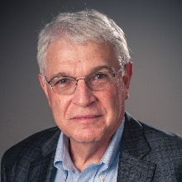 | john@hammerschlagparking.com
 |  | Haney, Mike R. |  | 2016
 | 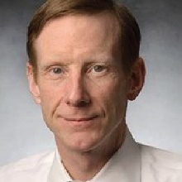 | Newcastle Limited
 |  | President & CEO
 |  | Bus: 150 N. Michigan Avenue, Suite 2700, Chicago, IL, 60601 |  | Bus: 312-252-1402
 |  | mhaney@newcastlelimited.com
 |  | Hanson, James M. |  | 2016
 |  | Avison Young
 | 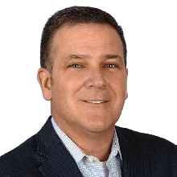 | Principal
 |  | Res: 52 Oak Avenue, Highwood, IL 60040 |  | Cell: 312-286-1136
 |  | Bus: One S. Wacker Dr, Suite 3000, Chicago, IL, 60606 |  | Bus: 312-273-4506
 |  | James.hanson@avisonyoung.com
 |  | Hanson, Richard A. |  | 1985
 |  | (Senior member)
 |  | Avison Young
 |  | Principal & Developer
 | 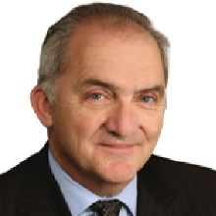 | Res: 441 N. Bruner Place, Hinsdale, IL, 60521 |  | Cell: 312-287-2494
 |  | Bus: One South Wacker Drive, Suite 3000, Chicago, IL, 60606 |  | Bus: 312-273-4505
 |  | richard.hanson@avisonyoung.com
 |  | Harrison, Jonathan G. |  | 2011
 |  | Adams LaSalle Realty Partners, LLC
 |  | Res: 841 Shiloh Circle, Naperville, IL, 60540 |  | Cell: 630-747-9546
 | 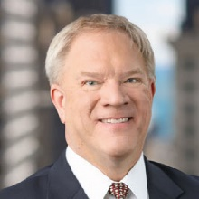 | Bus: 30 South Wacker Drive, Suite 2855, Chicago, IL, 60606 |  | Bus: 312-983-7091
 |  |  | Harwood, Peter G. |  | 2025
 |  |  | Newmark
 |  |  | Senior Managing Director
 |  |  | Res: 4611 N. Hermitage Avenue, Chicago IL, 60640
 |  |  | Bus: 500 West Monroe Street, 29th Floor, Chicago, IL, 60661 |  | Cell: 312-909-0393
 |  |  | peter.harwood@nmrk.com
 |  | Haymaker, Terri |  | 2020
 |  | The Planera Group
 |  | Res: 9956 S. Bell, Chicago, IL, 60643 |  | 773-330-7093
 |  | Bus: 111 N. Wabash Ave. Suite 100-3263 Chicago IL 60602
 |  | Terri.Haymaker@PlaneraGroup.com
 |  | Hendrickson, Terry |  | 2012
 |  | Old Republic Title
 |  | Vice President - Commercial Sales
 |  | Res: 60 Boardwalk Place, Park Ridge IL, 60068 |  | Cell: 312-622-3050
 | 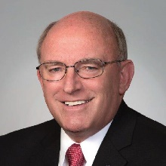 | Bus: 20 South Clark St, Suite 2900, Chicago, IL, 60603 |  | Bus: 312-839-2603
 |  | thendrickson@oldrepublictitle.com
 |  | Hiffman, Dennis J. |  | 1986
 |  | NAI HIFFMAN
 |  | Chairman & Founder
 | 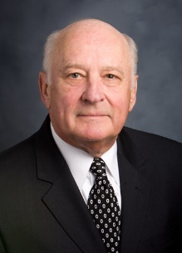 | Res: 2045 Autobahn Way So, Joliet IL, 60436 |  | 312-505-3555
 |  | Bus: One Oakbrook Terrace, Suite 400, Oakbrook, IL, 60181 |  | Bus: 312-505-3555
 |  | dhiffman@hiffman.com |  | Fax: 630-932-7258
 |  | Houston, Michael A. |  | 2023
 |  | Jacobs
 |  | Vice-President - Client Accounts
 |  | Res: 4161 S. Berkely Avenue, Chicago, IL, 60653 |  | Cell: 630-854-3525
 |  | Bus: 525 W. Monroe Street, Suite 1600, Chicago, IL, 60661 |  | Bus: 630-854-3523
 |  | Michael.Houston@jacobs.com
 |  | Huddlestun, Ryan S. |  | 2024
 |  | MidFirst Bank
 |  | Vice President/Relationship Manager |  | 847-767-5561
Res: 121 East Blodgett Avenue, Lake Bluff, IL 60044
Bus: 191 North Wacker Drive, Suite 1685, Chicago, IL 60606
 |  | Ryan.huddlestun@midfirst.com
 |  |  |  | 2001
 | 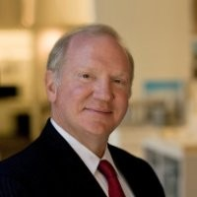
 |  | Jack, Brian M. |  | 2001
 |  | (Senior member)
 |  | Res: 4039 Bunker Lane, Wilmette, IL, 60091 |  | 312-714-4923
 |  | brian.m.jack@gmail.com
 |  | Joffe, Allen R. |  | 2004
 | 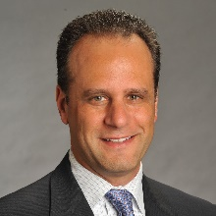 | First Street Retail Partners, LLC  Principal
 |  | Bus: 3735 Bordeaux Drive, Northbrook, IL, 60602 |  | Bus:224-355-2007
 |  | allen@firststreetretail.com |  | Cell: 312-401-5564
 |  | Lissner, Gail L. |  | 2009
 |  | Integra Realty Resources - Chicago
 |  | Managing Director
 |  | Res: 724 Woodridge Lane , Glencoe IL, 60022 |  | 847-835-8940
 |  | Bus: 1 N. Franklin Street, Suite 3340, Chicago, IL, 60606 |  | Bus: 312-565-3423
 |  | glissner@irr.com |  | Cell: 312-810-4343
 |  | Ludgin, Ph.D, Mary K. |  | 2001
 |  | Heitman
 |  | Managing Director & Director of Investment Research
 |  | Res: 534 N. East Avenue, Oak Park, IL, 60302 |  | 708-660-1309
 | 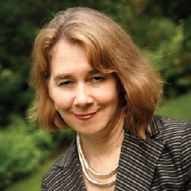 | Bus: 191 N. Wacker Drive, Suite 2500, Chicago, IL, 60606
 |  | mary.ludgin@heitman.com |  | Fax: 312-425-0765
 |  | Mattern, Lauren A. |  | 2025
 |  | Journey
 |  | Founder and Director |  | Cell: 415-652-2995
 | 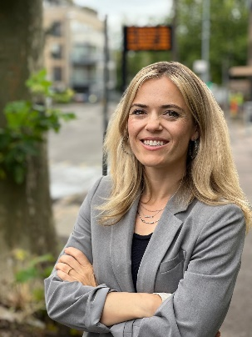 | 3033 N. Sheridan Road, Unit 401, Chicago IL, 60657  lauren@journeymobility.co
 |  | McIntosh, Bruce W. |  | 1984
 |  | (Senior member)
 |  | Res: 26385 W. Glenbarr Lane, Barrington, IL, 60010 |  | Cell: 847-380-0790
 |  | BruceWMcIntosh26@gmail.com
 |  | McKevitt, James M. |  | 1968
 |  | (Senior member)
 |  | Res: 4010 Arbor Lane #103, Northfield IL, 60093
 |  | jimmmckevitt@comcast.net
 | 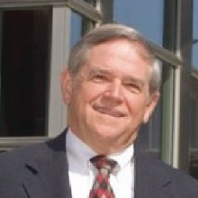
 |  | McKinney, Jack |  | 1993
 |  | (Senior member)
 |  | Res: 23 Alden Lane, Lake Forest, IL, 60045 |  | 847-295-0775
 |  | jackmckinney5@gmail.com
 |  | McSherry, Cindy |  | 2024
 |  | ULI Chicago
 | 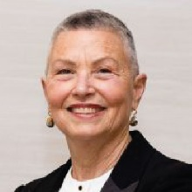 | Executive Director
 |  | Bus: 1700 W. Irving Park Road, Suite 208, Chicago, IL, 60613 |  | Bus: 773-549-4972
 |  | cmcsherry@mma90.com |  | Cell: 773-503-8962
 |  | Mitchell, Maxine |  | 2009
 |  | Applied Real Estate Analysis, Inc.
 |  | President
 | 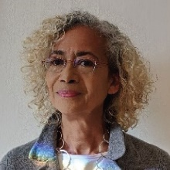 | Res: 3511 N. Fremont, Chicago, IL, 60657 |  | 773-327-4829
 |  | Bus: 914 S Wabash, , Chicago, IL, 60605 |  | Bus: 312-461-9332
 |  | mmitchell@areainc.net |  | Fax: 312-461-0015
 |  | Moody, Palmer “Pete” D. |  | 1969
 |  | (Senior member)
 |  | Res: 3116 Cleveland Avenue, Michigan City IN, 46360 |  | Cell: 708-601-4447
 |  | moody9752@comcast.net
 |  | Morrison, Heather |  | 2023
 | 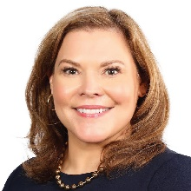 | Morrison Architectural Planning Strategies (MAPS)
 |  | Founder & CEO |  | Cell: 773-351-9482
 |  | Bus: 200 N Lasalle St, Suite 2925, Chicago, IL 60601 |  | Bus: 312-345-6277
 |  | hmorrison@map-strategies.com
 |  | Munin, Brian E. |  | 2025
 |  | Managing Director |  | Cell: 708-404-5498
 |  | Res: 2044 W. Roscoe, Unit 2N, Chicago IL, 60618 |  | Bus: 312-784-2767
 | 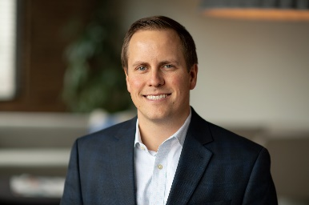 | Bus: 176 N. Racine Avenue, Suite 200, Chicago, IL, 60607
 |  | bmunin@mccafferyinc.com
 |  | O'Connor, Patrick |  | 2017
 |  | Farpoint Development
 |  | Principal
 |  | Res: 2753 Woodbine Avenue, Evanston, IL, 60201 |  | Cell: 312-617-5968
 |  | Bus: 120 N. Racine , Suite 200, Chicago, IL, 60607 |  | Bus: 312-971-0579
 |  | poconnor@farpointdev.com
 |  | Pachucki, Gary |  | 2007
 |  | IBT Group, LLC
 |  | Principal
 |  | Res: 1 East Schiller Street, 21D, Chicago, IL, 60610 |  | Cell: 773-727-4280
 |  | Bus: 1354 N. Kostner Avenue,, Chicago, IL, 60651 |  | Bus: 312-421-8703
 |  | gpachucki@ibtgroupllc.com |  | Fax: 312-421-3331
 |  | Page, Carter |  | 2013
 |  | Draper and Kramer, Inc.
 |  | Vice President
 | 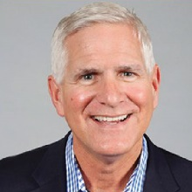 | Res: 651 Driftwood, Northbrook, IL, |  | Cell: 847-651-4526
 |  | Bus: 55 East Monroe Street, Suite 3900, Chicago, IL, 60603 |  | Bus: 312-580-6542
 |  | pagec@draperandkramer.com
 |  | Parang, Farzin |  | 2021
 |  | Building Owners & Managers Association of Chicago
 |  | Executive Director |  | Cell: 773-485-0670
 |  | Bus: 190 S. LaSalle St, Suite 2500, Chicago, IL, 60603 |  | Bus: 312-870-9610
 |  | fparang@bomachicago.org
 |  | Philipsborn, Andrew I. |  | 2008
 |  | The Philipsborn Company
 |  | President
 |  | Res: 1000 W. Washington, #503, Chicago, IL, 60607 |  | Cell: 312-758-5555
 | 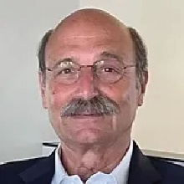 | Bus: 205 West Randolph Street, Suite 1010, Chicago, IL, 60606 |  | Bus: 312-207-5555
 |  | aphilipsborn@philipsborn.com
 | 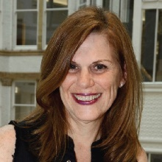
 |  | Protas, Janet |  | 2019
 |  | SVP Multifamily Development
 |  | Res: 130 N. Garland Ct, Suite 2304, Chicago, IL, 60602 |  | Cell: 917-608-0552
 |  | jprotas@protas.net
 |  | Puppi, Justin J. |  | 2022
 |  | CBRE
 |  | Vice President
 |  | Res: 11220 Como Ct, Lemont, IL 60439 |  | Cell: 312-459-1069
 |  | Bus: 321 N. Clark Street, Suite 3400, Chicago, IL, 60654 |  | Bus: 312-861-7839
 |  | justin.puppi@cbre.com
 |  | Qualkinbush, Steve R. |  | 2025
 |  | Principal
 |  | Res: 2421 Simpson Street, Evanston IL, 60201 |  | Cell: 312-446-7656
 |  | Bus: P.O. Box 8106, , Evanston IL, 60204
 |  | steve@q2re.com
 |  | Quast, Robert |  | 2002
(Senior member)
Retired/Green Valley AZ Volunteer
 | 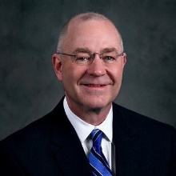 | Res: 1081 Vuelta Del Yaba, Green Valley AZ, 85622 |  | Cell: 630-935-8777
 |  | REQuast@comcast.net
 |  | Quast, Tyler R. |  | 2016
 |  | Blue Star Properties
 |  | COO
 |  | Res: 839 S. Stough, Hinsdale, IL, 60521 |  | Cell: 708-712-5401
 |  | Bus: 600 W. Van Buren, Suite 1000, Chicago, IL, 60607 |  | Bus: 312-855-2222
 |  | tyler@bluestarproperties.net
 |  | Rider, Harold D. |  | 1975
 |  | (Senior member)
 |  | President
 | 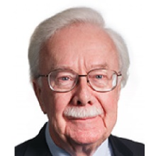 | Res: 109 Otis Road, Barrington, IL, 60010 |  | 847-381-1254
 |  | Bus: 1509 West Berwyn Ave, Suite 200, Chicago, IL, 60640 |  | Bus: 773-989-8000
 |  | hdr@realtymortgageco.com |  | Fax: 773-989-6979
 |  | Scherb, Jr., Albert H. |  | 2002
 |  | (Senior member)
 |  | Retired
 |  | Res: P.O. Box 8, Ellison Bay WI, 54210 |  | Cell: 312-342-9920
 |  | bscherb7@gmail.com
 |  | Six, Robert M. |  | 1995
 |  | (Senior member)
 |  | Res: 222 North Columbus Drive, Unit 3310 Chicago, IL 60601 |  | 312-961-9248
 |  | rmjsix@gmail.com
 |  | Stables, J. Mark |  | 1999
 |  | (Senior member)
 |  | Retired (Former Principal Avison Young)
 | 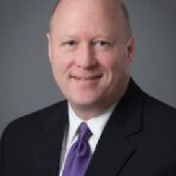 | Res: P.O. Box 389, 7130 Huntington Dr, Sawyer MI, 49125 |  | Cell: 708-951-3205
 |  | johnmarkstables@gmail.com
 |  | Taylor, Jason |  | 2025
 | 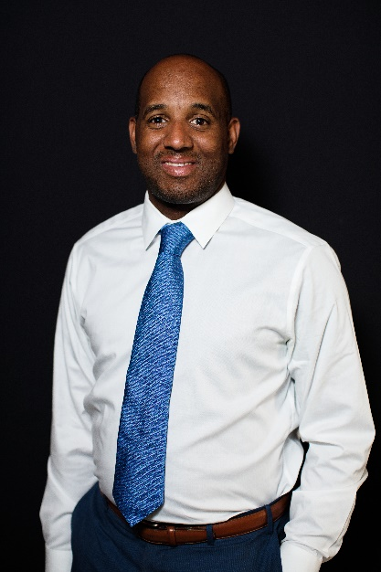 | The Annex Group  Managing Partner, Public-Private Partnerships
 |  | Res: 1714 W Huron Street, Chicago, IL 60622 |  | 312-286-7005
 |  | Bus: 409 Massachusetts Ave #300, Indianapolis, IN 46204
 |  | jtaylor@theannexgrp.com
 |  | Tjarksen, Susan |  | 2020
 |  | Cushman & Wakefield
 |  | Managing Director, Multifamily Capital Markets
 |  | Bus: 225 West Wacker Drive, Suite 3000, Chicago, IL, 60606
 | 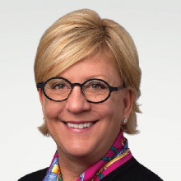 | susan.tjarksen@cushwake.com |  | Cell: 312-523-7617
 |  | Tortorello, Peter |  | 2018
 |  | Fairfield Properties, LLC
 | 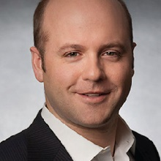 | Principal
 |  | Res: 642 S. Madison, Hinsdale, IL, 60521 |  | Cell: 312-399-2505
 |  | Bus: 330 West Chestnut, , Hinsdale IL, 60521
 |  | peter@fairfieldproperties.net
 |  | Vance, Steven
 |  | Chicago Cityscape |  | 2022
 |  | CEO
 |  | Res: 800 S. Wells Street, Ste 939, Chicago, IL, 60607 |  | Cell: 312-945-9621
 |  | Bus: 800 S. Wells Street, Suite 939, Chicago, IL, 60607
 |  | steven@chicagocityscape.com
 |  | Walker, Leon I |  | 2016
 |  | DL3 Realty, LP
 |  | Managing Partner
 |  | Bus: 77 West Washington St, Suite 405, Chicago, IL, 60602 |  | 773-721-3400x11
 |  | lwalker@dl3realty.com |  | Cell: 773-844-3381
 |  | Wasilowski, Steven P. |  | 2007
 |  | Retired
 | 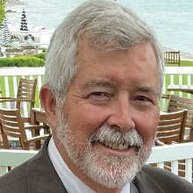 | Res: 324 Vincent Place, Elgin IL, 60123 |  | 847-754-5095
 |  | steve.wasilowski@gmail.com
 |  | West, Arthur C. |  | 2002
 |  | (Emiritus member)
 | 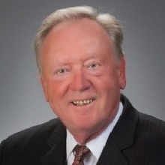 | Retired
 |  | Res: 270 Village Dr, Unit 1207, Downers Grove IL, 60516 |  | Cell: 312-952-1002
 |  | arthurcwest@comcast.net
 |  | Whitney, Richard L. |  | 2022
 |  | Fitzgerald Associates Architects, PLLC
 |  | Vice President
 |  | Res: 2635 North Drake Avenue, Chicago, IL, 60647 |  | Cell: 312-296-2742
 |  | Bus: 200 West Adams Street, Suite 2100, Chicago, IL, 60606 |  | Bus: 312-252-9209
 |  | rwhitney@fitzgeraldassociates.net
 |  | Wigle, K.C.
 |  | W.E. O'Neil Construction
 |  | Vice President
 |  | Res: 64 Exmoor Ave, Glen Ellyn, IL 60137 |  | Cell: 773-354-5071
 |  | Bus: 1245 West Washington St, Chicago, IL, 60613 |  | Bus: 773-354-5071
 |  | kcwigle@weoneil.com
 |  | Wuorenma, Ruth |  | 2019
 |  | Retired Developer, with continuing advocacy for
 |  | nature, resilient infrastructure and good governance
 |  | Res: 966 S. Park Terrace, Chicago, IL, 60605  Res: 1266 Buffalo Rd, Galien, MI. 49113 |  | Cell: 312-218-8136
 |  | Ruthann.wuorenma@gmail.com
 |  | Zeller, Paul |  | 1995
 |  | (Senior member)
 |  | Zeller Realty Group
 | 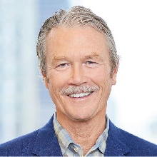 | Res: 21 Locust Road, Winnetka, IL, 60093 |  | 847-784-1601
 |  | Bus: 401 N. Michigan Avenue, Suite 250, Chicago, IL, 60611 |  | Bus: 312-640-7600
 |  | pzeller@zellerrealty.com |  | Fax: 312-640-7699

